Project Proposal for HPC Access
Period
Give the granting period you apply for (month year - month year)
Project title
Title as given in the online proposal
Type of project
Either “new project” or “project extension”
HPC system(s)
Please name the HPC system(s)/module(s) for which you are applying
Project ID or Project Acronym
Please provide in case of a project extension
Principal investigator
Name, affiliation, address
Project contributor(s)
Name, affiliation, address

The length of the project description is restricted to 18 pages (font 11 pt)!

Contents
1 Introduction 3
2 Preliminary Work 3
3 Description of the Project 3
3.1 Project Details 3
3.1.1 Sub-project 1 3
3.1.2 Sub-project 2 3
3.2 Review Processes 3
4 Numerical Methods and Algorithms 4
5 Computer Resources 4
5.1 Code performance and workflow 4
5.2 Justification of number of core hours requested 5
6 Resource Management and Work Schedule 6
6.1 Resource management 6
6.2 Work schedule 7
6.2.1 Sub-project 1 7
6.2.2 Sub-project 2 7
7 Key Personnel and Experiences 7
8 Bibliographic References 7

Introduction
Give a short outline of the scientific background of your research, including references.
(about 0.5 to 1 page)

Preliminary Work
Provide a brief summary of your preliminary work in connection with the proposed project, including references documenting the experience and preliminary work of the PI and project contributors in the field.
(about 1 to 2 pages)

Description of the Project

Project Details
Describe your research project in detail, structured in sub-projects, if applicable. Please include the following points:
- Scientific questions you want to address
- Scientific objectives
- Computational objectives
- Approach and expected outcome
- Expected impact on the research area
- Scientific and technical innovation potential, impact and topicality

Sub-project 1

Sub-project 2
...
(1 to 2 pages per sub-project)

Review Processes
Has the underlying research project already successfully undergone a scientific review process? Is the project funded by public money? If yes, please also provide information about the funding source (e.g. State, BMWi, BMBF, DFG, EU,$…$)

Numerical Methods and Algorithms
Describe the numerical methods and algorithms that you are planning to use, improve, or develop.
(1 to 2 pages)

Computer Resources

Code performance and workflow
Describe all codes, packages or libraries that you need to undertake the project, and how these will enable the research to be achieved. Include for each code to be used information about (if applicable)
- Which code will be used
- On which hardware the code will be used (CPUs, GPUs, etc. or combinations, if
applicable)
- How the code is parallelized (pure MPI, mixed MPI/OpenMP, Pthreads, CUDA, etc.)
- The amount of memory necessary (per core, per node and in total)
- Scaling plots and tables with speedup results for runs with typical, parameter sets, problem size, and I/O of the planned project (no general benchmark results are accepted). Scaling data should start with the lowest number of cores possible.
- Describe architecture, machine/system name, and problem size used for the scaling plots
- Current job profile (independent jobs, chained jobs, workflow, etc.)
Important: please take into account the corresponding technical guidelines and requirements (e.g. required minimal code scalability, memory restrictions, etc.) of the machine you have chosen!
If you use third-party codes, include
- Name, version, licensing model and conditions
- Web page and other references
- Contact information of the code developers.
- Your relationship to the code (developer, collaborator to main developers, end user, etc.)
Here we give an example table and plot for presenting scaling and performance information. Let the scaling start with one core or, if not possible, with the lowest number of cores possible for your case. Please replace the text in Courier by the appropriate information.
Table 1: Scaling behavior of code on architecture and system at location. This test was performed with 5⋅10⁶ particles, absolute timings per time step (s) and relative speedup normalized to 1 core are given.
#cores | absolute timing (s) | speedup | Performance per core [MFLOP/s]
1 | 3781.2 | 1.0 | 800
2 | 1890.6 | 2.0 | 800
4 | 945.3 | 4.0 | 800
8 | 472.7 | 8.0 | 800
16 | 236.3 | 16.0 | 800
32 | 118.1 | 32.0 | 800
64 | 59.1 | 64.0 | 800
128 | 32.8 | 115.2 | 720
256 | 18.4 | 204.8 | 640
512 | 10.5 | 358.4 | 559
1024 | 6.2 | 614.4 | 480
2048 | 3.7 | 1024.0 | 400
4096 | 2.3 | 1638.4 | 320

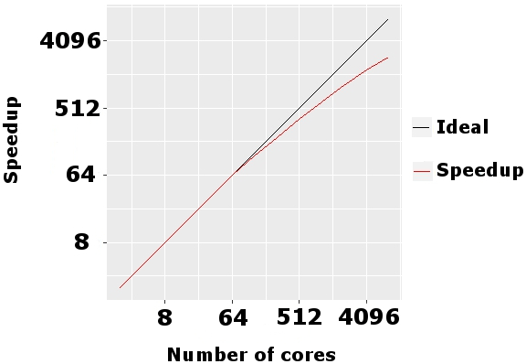
Figure 1: Scaling behavior of code on architecture and system at location. This data was obtained with a problem size of size.
(1 to 2 pages)

Justification of number of core hours requested
Outline the amount of resources you request for the current granting period, structured in sub-projects, if applicable.
If you are requesting different types of resources (e.g. CPUs, GPUs, etc.), please provide the following information and table for each type of resource separately and use the unit “core hours” (core-h) or for resources on the D-Wave AdvantageTM quantum system the unit “hours”. For GPUs please specify the resources in terms of core hours of the corresponding host CPUs. If you request resources on several HPC systems or modules, please justify why this is necessary for your project.
- Type of run (e.g. pre- /post-processing run, production run, visualization, etc.)
- Problem size for planned runs (e.g. # particles or the like)
- Number of runs planned
- Number of steps per run
- Wall-clock time per run
- Number of cores used per run (for GPUs: number of cores of the host CPUs)
- Total amount of requested computing time in core-h or in hours for D-Wave resources
- Resources for data analytics, if applicable

Table 2: The following CPU resources are requested
Sub-project | Type  of run | Problem  size | # runs |  | # steps/  run | Wall time/  step [hours] |  | #cores/  run | Total  [core-h]
Sub-proj. 1 | Preproc | P1 |  | R1 | S1 | W1 | C1 |  | R1$⋅$S1$⋅$W1$⋅$C1
 | Type 1 | P2 |  | R2 | S2 | W2 | C2 |  | R2$⋅$S2$⋅$W2$⋅$C2
$$⋯$$ | $$⋯$$
TOTAL |  |  |  |  |  |  |  |  | sum of above

Table 3: The following GPU resources are requested
Sub-project | Type  of run | Problem  size | # runs |  | # steps/  run | Wall time/  step [hours] |  | #host cores/  run | Total  [core-h]
Sub-proj. 1 | MD 1 | P3 |  | R3 | S3 | W3 | C3 |  | R3$⋅$S3$⋅$W3$⋅$C3
 | MD 2 | P4 |  | R4 | S4 | W4 | C4 |  | R4$⋅$S4$⋅$W4$⋅$C4
$$⋯$$ | $$⋯$$
TOTAL |  |  |  |  |  |  |  |  | sum of above

Table 4: The following D-Wave AdvantageTM resources are requested
Sub-project | Type  of run | Problem  size | # runs |  | Wall time/  run [hours] |  | Total  [hours]
Sub-proj. 1 | Type 2 | P5 |  | R5 | W5 | R5$⋅$ W5
 | Type 3 | P6 |  | R6 | W6 | R6$⋅$ W6
$$⋯$$
TOTAL |  |  |  |  |  | sum of above

(0.5 to 1 page)

Resource Management and Work Schedule

Resource management
Describe how you intend to manage the resources you have requested. This should include a description of the methods you will deploy to monitor progress of the project and how project results are documented.
(0.5 to 1 page)

Work schedule
Please provide a short work schedule, structured in sub-projects, if applicable. Include a table and/or Gantt chart.

Sub-project 1
...

Sub-project 2
...
Example for a Gantt chart:
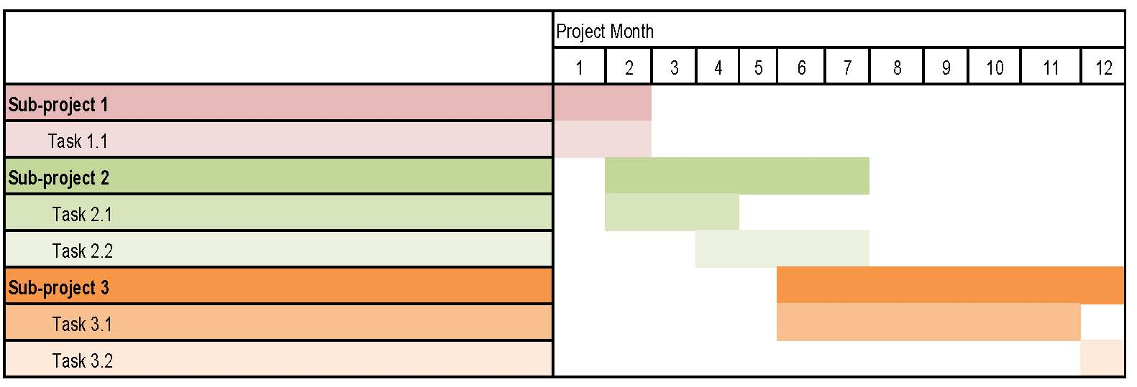
Figure 2: Work schedule for the project.

Key Personnel and Experiences
Give a short introduction of the key persons involved in the project and their experience (max 3 persons).
(half a page)

Bibliographic References
Provide recent/most important bibliographic references that are relevant to the project and document the experience and preliminary work of the PI and project contributors in the field.

